RYAN AVERY

and

2HEMISPHERES

Develop and Deliver Winning Presentations  
October 2014

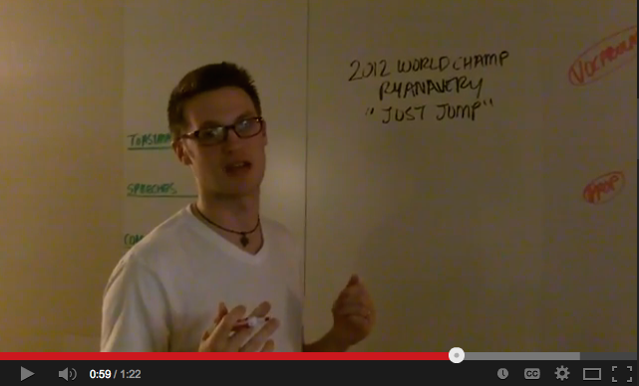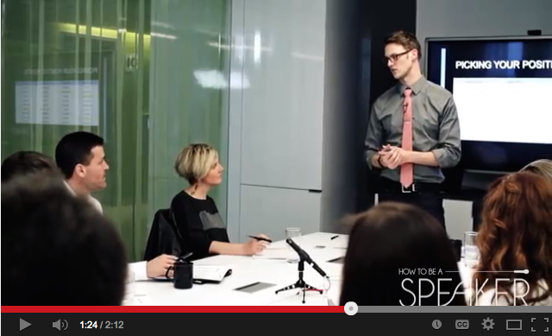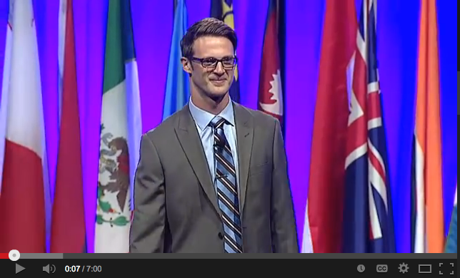

**Ryan Becomes the Youngest World Championship of Public Speaking in History**

In August 2012, at the age of 25 and after competing against more than 30,000 people from 116 countries, Ryan becomes the youngest World Champion of Public Speaking in history.

The next morning, he wakes up to 269 emails asking him to coach and speak all over the world. With the help of his friends, family, wife and mentors –Ryan takes his speaking full-time eight months after his Championship win.

Six months later he writes his first book published by McGraw-Hill titled *Speaker Leader Champion* that hits #1 on Amazon and is already translated into four languages.

**Ryan Now Trains Leaders around the World How to Influence Through Storytelling**

With what he learned during the World Championships and now being a full-time speaker and trainer, Ryan works with leaders around the world teaching them how to deliver and develop winning presentations.

He uses his millennial mindset, professional experiences and personal life stories to show leaders how to sell, persuade and build relationships that generate business.

From Rhode Island, to Russia from Boston to the Bahamas, Ryan delivers nearly 100 presentations a year while being the founder of two companies focusing on training leaders to be better speakers.

**Ryan Posts a Video Stating He Will Become the World Champion of Public Speaking**

In January 2012, Ryan is being a normal 20-something watching several hours of YouTube videos one Saturday morning.

He sees a video of someone going for the World Champion of Public Speaking and gets the idea he can do it! Never giving a professional speech in his life, he asks his wife to coach him and they get started.

He trains for eight months, receives over 1,000 individual evaluations on his speeches and practices everywhere he can to get over his lack of confidence. This includes speaking in the middle of Pioneer square during rush hour, over the intercom on a full flight, and even in the stinky gym sauna!

**The art of storytelling is the language of selling!**

Let’s bring together one of the strongest retail agencies in the world and partner them with a millennial who knows how to use the strategies, secrets and insights from the world’s greatest speakers to influence decision makers to take action.

Let’s teach the team at 2Hemispheres how to develop and deliver winning presentations that build relationships, increase profits and empower individual team members to present with power.

Take a look at the pages that follow in this proposal to see what can come from 2Hemispheres and Ryan Avery joining forces.

Together we will…

Increase Your

PROFITS

Expand Your

INFLUENCE

Develop and Deliver Winning

PRESENTATIONS

Strengthen Your

CONFIDENCE

Build Stronger

RELATIONSHIPS

**What Will Ryan Do for 2Hemispheres?**

Ryan works with your leaders and team to develop and deliver winning presentations to. Ryan will:

**Analyze—** Ryan will gather, assess, and analyze information in order to identify problems, needs, and opportunities to help each executive improve their communication skills on and off stage.

**Design—** Ryan will create learning objectives, topics to be addressed, and create group and/or individual exercises for key takeaways.

**Develop —** Ryan will generate strategies designed to maximize each executive’s objectives to allow maximum improvement in the most appropriate amount of time.

**Implement —** Ryan will conduct trainings where the executives will have time to implement the strategies and receive feedback on their implementation.

**Evaluate —** Ryan will use the program evaluation created during the development phase to assess the effectiveness of the strategies and deliver in-person evaluation for each executive.



Similar Ingredients. Different Presentations.

*If your business was selling hamburgers, how are you presenting your product to the people making the purchase?*



**Empower Your Team:**   
Do you feel confident everyone on your team can land an account like adidas?

**Build Your Relationships:**

How will you grow your Nike business partnership?

**What does 2Hemispheres look like when working with Ryan?**

During and after working with Ryan your team will have:

1) Stronger relationships with current clients

2) Increased confidence in individual team members and their abilities to perform

3) Expanded your influence throughout the retail industry as the leader in retail design and strategy

4) Increased profits from team members developing and delivering winning presentations

5) Strategies to take your company to the level you know you are capable of performing at

Right now 2Hemisphers is Michael Jordan before he won his first Championship. You are Good, really good but think about how much more business, how many more partners and how many more opportunities he got after his sixth Championship? Let’s take you to the next level in your abilities to develop and deliver winning presentations!





**Increase Your Profits**:  
Are you getting all the business you want from Columbia?

**What Ryan Looks for in a Business Partnership!**

**Teams with Growth Potential**

Is there room to grow in your company? Do you want to reach the next level? Ryan wants to work with teams and leaders who are eager and ready to take the next steps to expand their reach.

**A Company Willing To Take Risks**

*“If you don’t like change, you will like irrelevance even less!”* Companies who have leaders willing to take calculated risks for the greater good of business will be the ones who survive over time and blaze the trail for the rest.

**Long Term Relationships**

No one benefits from a “hi and bye” type relationship. Let’s figure out ways we can work together to build a relationship that grows over time and makes us better, stronger and more efficient.

**Industry Connections**  
Working with teams who can open doors and connect Ryan to other clients that want to develop and deliver winning presentations.

**Make a Difference and Have Fun**

Ryan wants to work with companies who care about making a difference in their communities, teams and self. He has fun, utilizes a creative approach and lives by, “if you give more, you get more!”

2015 Investment

**Twelve Sessions - $45,000**

Six Sessions– $25,500

One Sessions - $5,000

In 2015, Ryan will increase his fees.   
The 2014 investment applies when partnership forms this calendar year.

**Twelve Sessions - $28,000**

Six Sessions– $19,500

One Sessions - $3,800

2014 Investment

Next Step: set up an in person meeting with Ryan to discuss options in more details.

Ryan Avery | Speech is Power | ryan@averytoday.com | www.RyanAvery.com | 409.200.4774

**Why Leaders Trust Ryan?**

**Tremendous Value**

Ryan is more than an award-winning storyteller and trained motivational speaker. Ryan gives tangible strategies, business examples and easy to implement takeaways to improve all areas of your attendees lives! Companies and organizations around the world trust Ryan to help their leaders communicate effectively to enhance their businesses, motivate their employees, and add value to their clients.

**Best-Selling Author**

Ryan sold and signed 1,300 books at his first USA signing for his new book, *Speaker*, *Leader, Champion*: *Succeed at Work Through The Power of Public Speaking*. It is a #1 best selling book on Amazon, has been translated into three languages and has sold thousands of copies worldwide.

**World Champion**

Ryan became the youngest World Champion of Public Speaking in History in 2012 after competing against more than 30,000 people from 116 countries. He is a proud member of The National Speakers Association (NSA) and continues to be recognized for his unique speaking style.

**Proven Trainer**

From Rhode Island to Russia, from Boston to the Bahamas, Ryan delivers nearly 100 presentations a year and has delivered value to hundreds of audiences around the world.

**Easy and Fun to Work With**

From the initial phone call to following up, Ryan and his teamwork to build relationships with you and make it easy for you to stay in touch, reach out, and follow up.

**What Leaders Say About Ryan and His Trainings**

*“Excellent content and great delivery. Pertinent and relevant for anyone that needs to communicate and be heard.”****- Robert Vendryes, IBM***

*"I have not been exposed to many speakers able to present at your level and found your engagement, humor and ease of communication to be very relatable and genuine. Second, when I think about the benefits of clear and concise speech it is typically in the form of a one-to-many format and not necessarily in a conversational setting. Watching how you engaged with the audience in a more one-to-one manner and conducted yourself after the event was, for me, even more impressive than the workshop portion. The take away for me is to apply your communication commandments I normally associate with group speaking to my daily interactions with colleagues and clients. Thank you again for sharing your story with us and being so open." -* ***Richard A. Barker, Merrill Lynch***

*"Ryan is the most real and enthusiastic speaker I have heard in some time. He shows all his tools to make you successful. He is confident in his own right, so does not hold anything back. Every minute was packed with value." -* ***Eva Tafoya, Blue Cross Blue Shields***

*“Ryan definitely has crafted a great teaching method out of his real life experience of winning the championship. His session not only included great advice for speaking but also for life.” -****Shan Khan, Wells Fargo***

*“I have been to a lot of trainings and seminars, and this was the best. I got a lot of concrete, usable tips to make my speaking better.”****- Mary Mattran, Intel***

*“Ryan has a great way of presenting something that seems so difficult but making it applicable and engaging. I definitely will be able to use these skills in my daily practice, research presentations and briefings. Thank you Ryan for a great workshop!”****- Danielle Anderson, United States Air Force***

*“Wow! What a dynamic, interesting presentation! I would recommend Ryan’s presentation to anyone who would like to be a better communicator-at any stage you may be in with your life.”****- Rebecca Fischer, Mary Kay Cosmetics***

*“Ryan, the level of participation, and enthusiasm you got out of our employees was amazing! They are never that involved. How did you do that? You did a great job grabbing everyone’s attention and holding it through the different phases of the workshop. What I really liked was that you tailored your presentation to the needs of each employee, and let them individually guide where your presentation was but lead the dialogue with such finesse that it felt more like a round table discussion. We all left with something we can use to improve our personal and professional life. We would see more results and more efficiency in the work place if more people knew your communication commandments. Thank you for being here today and we can’t wait to have you back to help us all grow even more.”****Jesse Cathey, Bank of America***

*“Ryan, when you gave your workshop for the National Speakers Association of Oregon Speakers Academy, you had all of our seasoned as well as our new speakers simply riveted. We admire your passion, your discipline and your great humor in sharing the mechanics of winning speeches and speaking.  -****Jan Carothers, National Speakers Association of Oregon***

*“I really enjoyed my time during Ryan’s workshop-I never realized that there is so much I didn’t know about public speaking! He was dynamic, entertaining and informative. I recommend this program to anyone, anywhere! He’s also very humble and not condescending.”****-Nichole Frazier, Staples Advantage-Team Lead***

*\* It’s ok, you can call or text me to set up a meeting!   
I am a millennial! My cell is 409-200-4774.*

Thank you!